Working with Google Data Visualizations

Using Treemaps with Drilldown
In this exercise we will create both a root query and a drill-down query in order to produce a web page with two visualizations, one representing the root query results and another representing the drilldown for a selected item from the first. In order to use this, your root query result needs to include a column named KEYWORD, which will be what is used as the label for whatever element the root visualization has. The drilldown query will include, in its WHERE clause, a condition like this: “where fldName = @VAL” (you pick the fldName). The symbol @VAL will be replaced from the value of the selected item in the root visualization. Thus, the visualizations will be interactive, with the user’s selection of an item from the root visualization triggering an event which produces the drilldown visualization.
You will do two of these. The first is something I specify. The second is anything of your choice.

Exercise #1: Treemap representing product categories and subcategories aggregating over (a) the total number of products and (b) the list price, with a barchart showing the list price of products with a selected subcategory.
When it first comes up, it should look something like this:
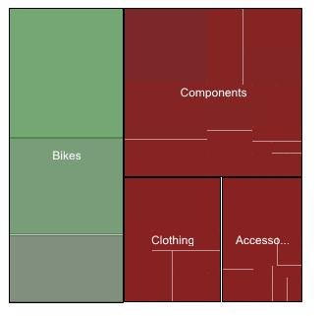
Select a category, and you’ll see subcategories. For bikes:
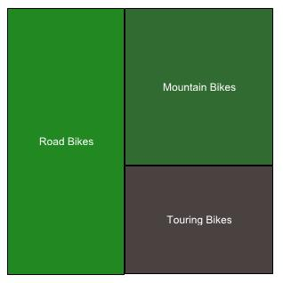

Select a subcategory and you’ll see a barchart of products. For touring bikes:
